# Additional Requirements

# Section 1: Catalog Item Definition

Refer to **Appendix A** for screenshots of the Service Portal highlighting the different elements.

Red Items = Required

| Attribute | Details | Guidance |
| --- | --- | --- |
| Name |  | Name of the catalog item as it will appear to end users. |
| Catalogs |  | The catalogs where this item can be found. |
| Categories |  | The categories the user can find this item under. |
| **Item Details** | | |
| Short description |  | A short description of the item.  This appears in the item’s tile when shown is a list. |
| Description |  | A longer description of the item.  This appears only at the top of the form. |
| Meta |  | Additional search terms for this item. |
| Delivery time |  | Shown to the user as an estimate for delivery. |
| **Picture** | | |
| Icon |  | This is only seen in the category view of the old Catalog Homepage.  It is not used in Service Portal. 27px by 27px. |
| Picture |  | The image users see when viewing this item in the Service Portal. |
| **Pricing** | | |
| Price |  | The one-off cost for this item. |
| Recurring price |  | The recurring charge for this item (e.g. monthly licence fee). |
| Recurring price frequency |  | How often the recurring price is charged. |
| Omit price in cart |  | Don’t display the price in the cart or catalog listing. |
| **Portal Settings** – These settings are unique to the item and override any default Service Portal settings. | | |
| Request method |  | Setting that controls the order submission experience.   * **Order Now**: Confirmation dialog with delivery info * **Request**: Confirmation dialog with no delivery info * **Submit**: Instant – no dialogs |
| Hide ‘Add to Cart’ |  | Selected by default if the Request method is Request or Submit. |
| Hide ‘Quantity’ |  | Selected by default if the Request method is Request or Submit. |
| Hide ‘Delivery time’ |  | Selected by default if the Request method is Request or Submit. |
| Hide ‘Add to Wish List’ |  |  |
| Hide Attachment |  | Users cannot add attachments |
| Mandatory Attachment |  | User must add at least 1 attachment |
| **User Criteria** | | |
| Available for |  | Users who can access this item. Can be defined as any of the following:   * Specific users * Groups * Roles * Companies * Locations * Departments * Advanced – scripted (potential performance implications) |
| Not available for |  | Users who are not allowed to access this item. |

# Section 2: Approvals

Approvals can be sequential (one after the other), parallel (all at once), or a combination of the two. Enter the same Order number for parallel approvals. Refer to **Appendix B** for example workflow patterns.

Approvers can be selected dynamically (e.g. the requestor’s manager), or they can be a set users or groups. Try to avoid single individuals as this creates a single-point-of-failure in the request process when that individual is unavailable.

Use Conditions to define when an approval should be included or excluded. E.g. “Exclude C-level executives from requiring manager’s approval”.   
Refer to **Appendix F** for example inputs.

| Order | Approvers (Users or Groups) | Conditions |
| --- | --- | --- |
| 1 | Group – Support, Financial, Functional, Approval, Ownership (Knowledge), fulfillment (Request)  User attributes – VIP, Business Unit, Title |  |
| 2 | Set of individuals – Can these individuals be put into a group? Tool constraint |  |
|  |  |  |
|  |  |  |
|  |  |  |

Enter the same Order number for parallel approvals

# Section 3: Fulfilment

## Requested Item (RITM)

| Attribute | Details | Guidance |
| --- | --- | --- |
| Assignment group |  | Required if catalog tasks are not used |
| Configuration item |  | Optional |

## Catalog Tasks

Tasks can be sequential (one after the other), parallel (all at once), or a combination of the two. Enter the same Order number for parallel tasks.   
Refer to **Appendix B** for example workflow patterns.

Use Conditions to define when a task should be included or excluded. E.g. “Only include ‘Install VLC media player’ task if that option was selected on the form”. Refer to **Appendix F** for example inputs.

| Order | Assignment group | Short description | Description | Condition |
| --- | --- | --- | --- | --- |
| 1 |  |  |  |  |
|  |  |  |  |  |
|  |  |  |  |  |
|  |  |  |  |  |
|  |  |  |  |  |
|  |  |  |  |  |

Enter the same Order number for parallel tasks

# Section 4: Variable Definition

Refer to **Appendix C** for screenshots of each variable type and a description of what they are used for.

Important: Use the table in **Appendix D** to copy-and-paste the required and optional configuration options for each type. Unused optional configurations don’t need to be included. Don’t forget the configuration options for all types.

Questions should be short and concise. For a better user experience, avoid redundant words, like “Please enter…”.

Refer to **Appendix F** for example inputs.

| Order | Type | Question | Required configuration | Optional configuration |
| --- | --- | --- | --- | --- |
| 1 | *Reference* | *Requested on Behalf of* | *Table: sys_user*  *Table Filter: Active Users* | *Mandatory when: Always*  *Read-only when: Never*  *Visible when: Always*  *Default Value: Logged in user*  *Help tag: NA*  *Help text: NA*  *Help always expanded: NA* |
| 2 |  |  |  | Mandatory when:  Read-only when:  Visible when:  Default Value:  Help tag:  Help text:  Help always expanded: |
| 3 |  |  |  | Mandatory when:  Read-only when:  Visible when:  Default Value:  Help tag:  Help text:  Help always expanded: |
| 4 |  |  |  |  |
| 5 |  |  |  |  |
| 6 |  |  |  |  |
| 7 |  |  |  |  |
| 8 |  |  |  |  |
| 9 |  |  |  |  |
| 10 |  |  |  |  |

## Multi-Row Variable Set Definition

These are sometimes called “table variables”. Refer to **Appendix E** for an explanation of multi-row variable sets.

Important: Use the table in **Appendix D** to copy-and-paste the required and optional configuration options for each type. Unused optional configurations don’t need to be included. Don’t forget the configuration options for all types.

Note that you cannot hide any variable in a multi-row variable set. This is like trying to hide a single cell in a table. You can only make the variable blank and read-only if it is not required.

| Minimum row count |  |
| --- | --- |
| **Maximum row count** |  |

| Order | Type | Question | Required configuration | Optional configuration |
| --- | --- | --- | --- | --- |
|  |  |  |  |  |
|  |  |  |  |  |
|  |  |  |  |  |
|  |  |  |  |  |

# Appendix A: Service Portal Elements

**Category Listing**

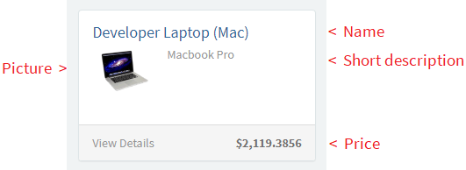

**Catalog item view**

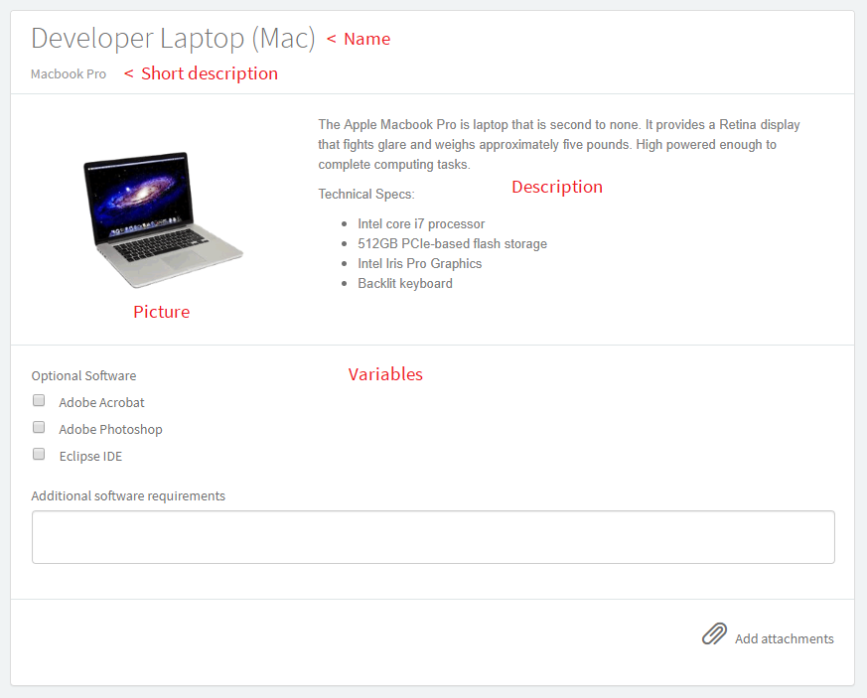

**Submit panel**

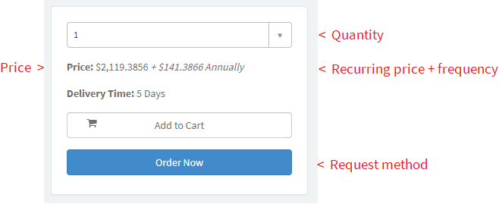

**Breadcrumbs**

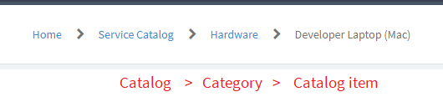

# Appendix B: Sequential vs Parallel

This section shows different workflow patterns for Approvals and Catalog Tasks.

**Sequential**

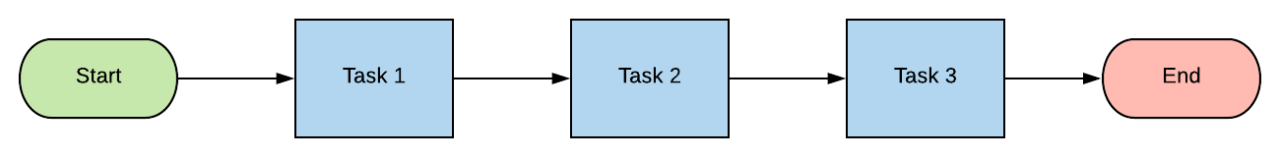

**Parallel**

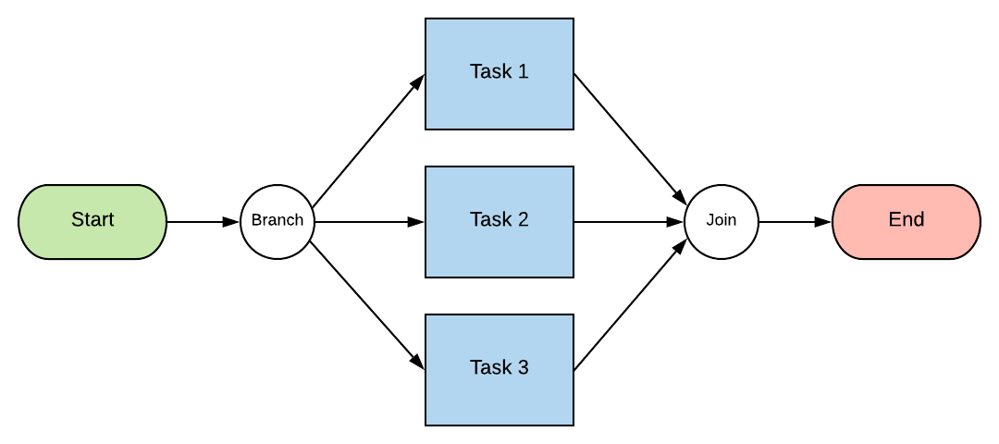

**Mixed – Sequential and Parallel**

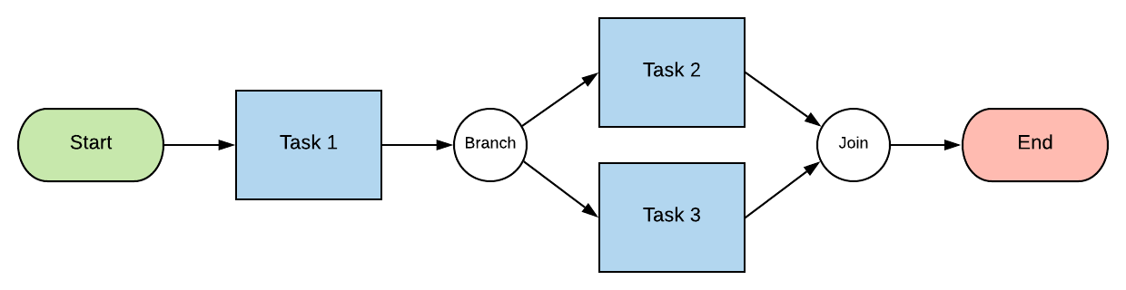

# Appendix C: Variable Types

**Single Line Text:** Free text input - limited to a single line (no line brakes). This type is also used for numbers (with input validation added).

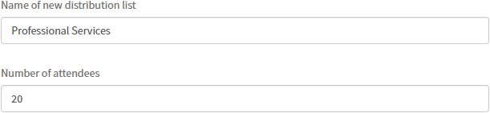

**Multi Line Text:** Free text input. Use this for large blocks of text.

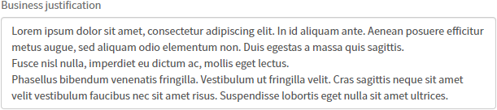

**Select Box:** Also known as a **drop-down list**, or **choice list**. Use this when there is a small number of specific options to select from (about 15 or less). The user can only select 1 option. Users can search the available options by typing some text.

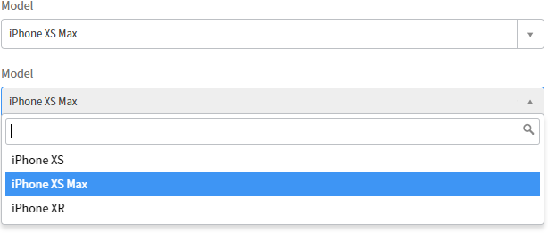

**Reference:** Also known as a **lookup field**. A reference field allows you to select a record that exists in ServiceNow. For example, it is commonly used to lookup an employee. Other examples can include Company, Department, Configuration item, Incident, Country, etc. The records you want to lookup must all be from the same table. For example, you can use a reference field to lookup Users, and another reference field to lookup Groups, but you cannot have one reference field that looks up both. It must be one table per reference field. You can specify a filter for the records to limit what the user can select. For example, active employees only.

The user can type in free text to search for an existing record, but they must select a record. You cannot submit the form with free text in the field.

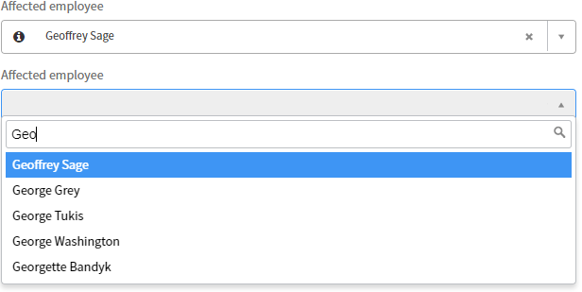

If you want the user to be able to select multiple records, use a **List Collector**.

**List Collector**: See **Reference** above. Allows the user to select multiple existing records from one table.

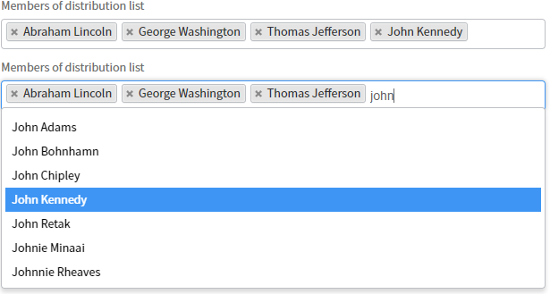

**Checkbox**: Checkboxes are commonly grouped together with a label. Checkboxes allow a user to select multiple options from a list.

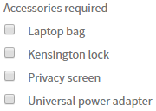

Another use for a checkbox is for a user acknowledgement.



**Date/Time**: Also known as a **date picker**. The user must enter a valid date and time. The user can type in a value manually, or they can use the date picker to search for and select a date and time. The format and time zone are automatically converted to the user’s preference (if specified), or defaults to the system default settings.

A **Date** field works the same but excludes the time input.



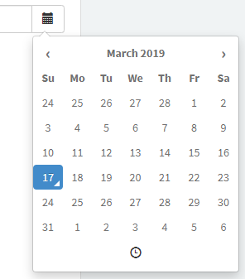 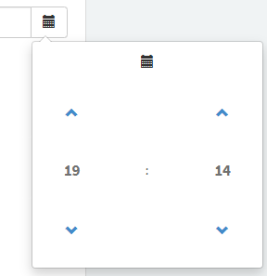

**Duration:** Allows the user to specify a duration of time in Days, Hours, Minutes and Seconds.



**HTML**: A HTML field allows the user to enter **formatted text**. It can contain images. The user can copy-and-paste content from Microsoft Word. Or the user can type in new content and use the available controls to format it.

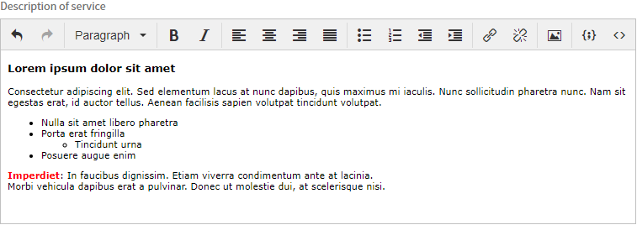

**Masked:** Commonly known as a password field. It can be used for any sensitive information. You can specify access roles to control who can see the data. As you type into the field, the value will be hidden by default. You can click the SHOW button on the right to see the value in plain text.

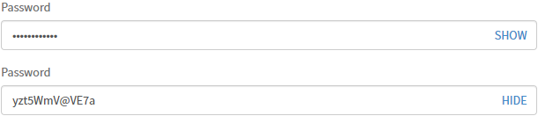

**Multiple Choice**: Also known as **radio buttons**. Use this type when the user must select exactly 1 option from a short, pre-defined list (about 6 or less). The options can be displayed horizontally or vertically.

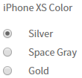

**Numeric scale**: Commonly used for a Likert scale. The user must select a number in the scale.



**Lookup Multiple Choice**: This field type combines a **reference** field and a **multiple-choice** list. The options are dynamically generated based on a list of records you specify in ServiceNow. The records must all be on one table. Examples can include Companies, Departments, Locations, etc. The user must select 1 option from the list. The options can be displayed horizontally or vertically. This type should only be used if the number of options is limited (about 6 or less).



**Lookup Select Box**: This field type combines a **reference** field and a **select box**. The options are dynamically generated based on a list of records you specify in ServiceNow. The records must all be on one table. Examples can include Companies, Departments, Locations, etc. The user must select 1 option from the list. This type should only be used if the number of options is limited (about 15 or less).

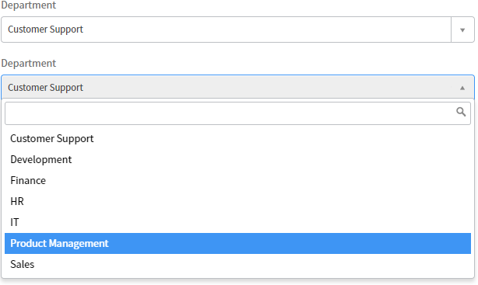

**Yes / No**: This type is just a shortcut for a **select box** with 2 options; **Yes** and **No**.



**Example Macros (custom widgets):**

A macro is custom code. The possiblities of what you can do with macors are almost limitless. They can be simple or complex. The following is a few examples of what is possible with macros.

**Static text and image**

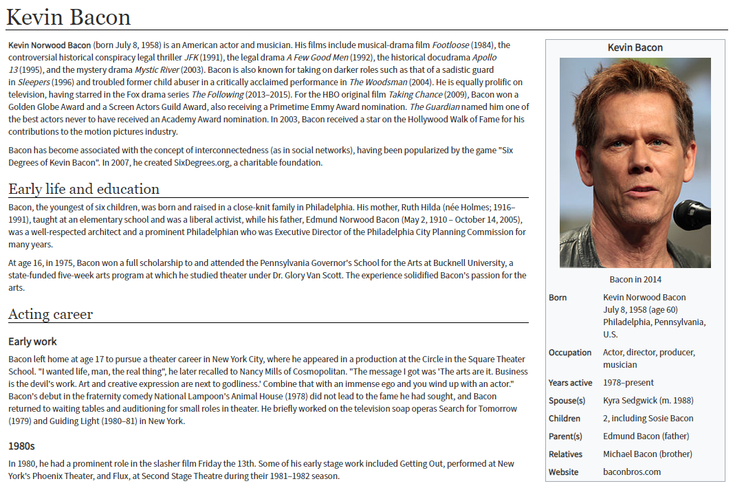

**Multi-row with CSV Loader**

Attach a CSV file to the catalog item. Click a button and the table is populated from the CSV file.

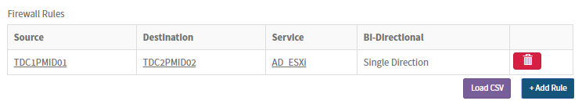

A model displays errors with individual rows:

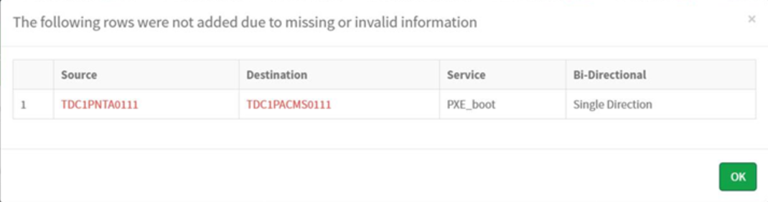

**Dynamic widget with client-side web service calls for selection options and inputs**

You select a subnet from the CMDB, then a web service call to an external system (IPAM) retrieves the available IP addresses for that subnet. The IP addresses from the external system are populated into the widget. You then select which IP address(es) you want to reserve. It is a real-time integration between two systems to ensure accurate data synchronization. The form changes dynamically depending on what subnet you select on the form, and the data for that subnet in the external system.

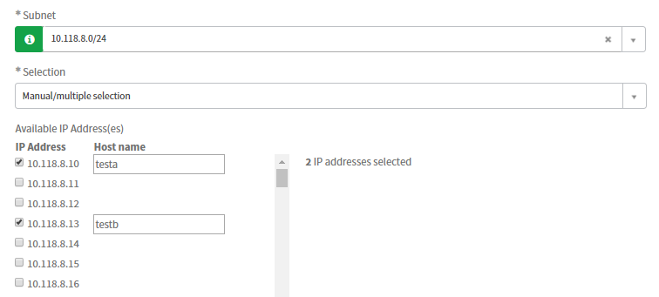

# Appendix D: Type Specifications

Use this table as a reference of the configuration options you need to provide for each variable in the next table, depending on its type.

| Variable Type | Required configuration | Optional configuration | Guidance |
| --- | --- | --- | --- |
| **All types** |  | Mandatory when:  Read-only when:  Visible when:  Default Value:  Help tag:  Help text:  Help always expanded: | All field types have these standard optional configurations. |
| Single Line Text (use for numbers) |  | Validation regex:  Input validation:  Placeholder: | Notes 1, 2 |
| Multi Line Text |  | Placeholder: | Note 2 |
| Select Box | Options: | Include none: | Notes 3, 5 |
| Reference | Table: | Filter: | Note 4 |
| Date |  | Input validation:  Placeholder: | Notes 1, 2 |
| Date/Time |  | Input validation:  Placeholder: | Notes 1, 2 |
| Checkbox |  |  | Note 5 |
| List Collector | Table: | Filter: | Like a reference field, but you can select multiple records. Note 4. |
| Duration |  | Input validation: | Note 1 |
| HTML |  |  |  |
| Masked (password) |  | Use confirmation:  Use encryption: | ‘Use confirmation’ creates a second input field that asks the user to re-enter the masked value. This is largely redundant with the introduction of the SHOW/HIDE feature in the London release.  ‘Use encryption’ stores the value in the database encrypted |
| Multiple Choice (radio buttons) | Options: | Direction:  Don’t select first choice: | Direction can be down or across |
| Numeric scale (radio buttons) | Min:  Max: | Don’t select first choice: |  |
| Lookup Select Box | Table:  Value field:  Label field: | Filter:  Include none: | Uses existing records to generate choices in a select box.  Notes 3, 4 |
| Lookup Multiple Choice | Table:  Value field:  Label field: | Filter:  Include none:  Direction: | Uses existing records to generate choices in a select box.  Note 4 |
| Yes / No |  | Include none: | It’s a select box with 2 options.  Note 3 |
| Label |  |  | Like a heading |
| Macro | Content: |  | Note 6 |

**Notes:**

1. Input validation uses a script. You must clearly define what you require. E.g. “Date must not be in the past”
2. A placeholder is grayed-out text in an input field used as an instruction or example input. It disappears once the user starts typing into the input.
3. Include none: This adds the “-- None --” option. If false, you must specify a default value.
4. A reference (or lookup) field selects an existing record.
   1. Table: The type of record. E.g. User, or Company
   2. Filter: A filter for the records, if you only want to show some records. E.g. Active users only, or Users from the ACME company.
5. For select boxes and checkboxes, it is possible to associate a price and recurring price to the option.
6. A macro is custom code. It can be almost anything, from an image or block of text, to an interactive widget. Speak to your Technical Consultant if you have requirements that cannot be met with the use of standard input fields.

**Permissions:**

This feature was introduced in the London release. You can define access roles on individual variables to control who can read and edit them. This is useful for sensitive information, like passwords, or personal information. Please specify these optional configurations for any variables that require them:

* **Create Roles**: User can edit the variable on the catalog item. If the user doesn’t have the role, the variable will be read-only on the catalog item.
* **Write Roles**: User who can edit the variable in the Variable Editor on the requested item. If the user doesn’t have the role, the variable will be read-only in the variable editor.
* **Read Roles**: User can see the variable on the catalog item and on the requested item. If the user doesn’t have the role, the variable will not be shown.

**Other Types:**

There are a few other field types not listed above: **IP Address**, **URL**, **Email**.  
It is recommended that these variable types are not used. There work by using input validation only when the form is submitted (Validation Scripts). This results in a poor user experience. If the user inputs an invalid value, they don’t find out until they see an error message when attempting to submit the form. It is recommended to instead use standard String fields with client-side input validation.

# Appendix E: Multi-Row Variable Sets

Multi-row variable sets are used for multi-row inputs. You can add as many items (rows) as you like when completing the catalog item. The header row is the variables. Each row after it is a group of inputs. The user can edit or delete individual rows. When the user clicks the ‘Add’ button, they see a popup modal (form) to capture the inputs for the next row.

You cannot include the following variable types in a multi-row variable set:

* HTML
* Label
* List Collector
* Macro

Example: You can use a multi-row variable set to request multiple firewall access rules:

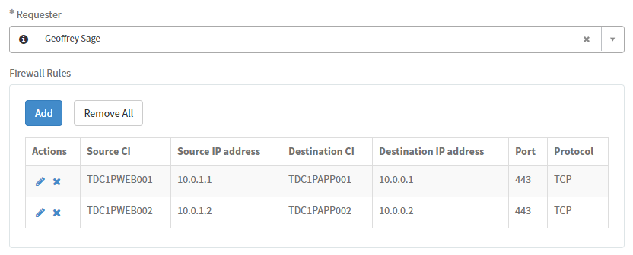

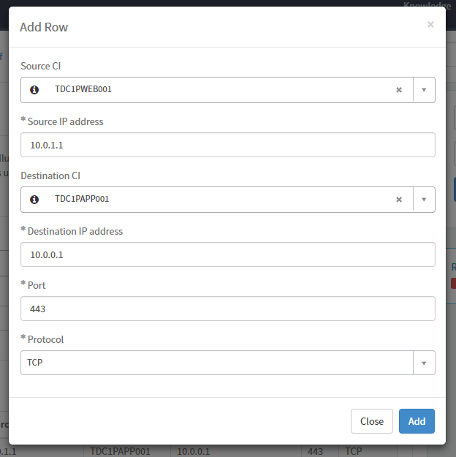

# Appendix F: Example Inputs

Scenario: New iPhone Request

**Approvals**

| Order | Approver (User or Group) | Conditions |
| --- | --- | --- |
| 1 | Requester’s manager | Exclude C-level executives |
| 2 | Workplace Services | Always |
| 2 | Mobility Support | Always |

**Catalog Tasks**

| Order | Assignment group | Short description | Description | Condition |
| --- | --- | --- | --- | --- |
| 1 | Mobility Support | New mobile device | Allocate new iPhone  Install AirWatch and register device | Always |
| 2 | Workplace Services | Deliver mobile device | Deliver mobile device to user.  Update CMDB. | Always |
| 3 | Desktop Support | Setup email on mobile device | Assist user is setting up email on mobile device | Only if ‘Do you require assistance with setting up email?’ is Yes |

**Variable Definitions**

| Order | Type | Question | Required configuration | Optional configuration |
| --- | --- | --- | --- | --- |
| 1 | Reference | Requested for | Table: User | Filter: Active users only  Mandatory when: Always |
| 2 | Select Box | Model | Options:   1. iPhone XS 2. iPhone XS Max 3. iPhone XR | Default value: iPhone XS  Include none: No |
| 3 | Select Box | Color (XS) | Options:   1. Silver 2. Space Gray 3. Gold | Mandatory when: Model is ‘iPhone XS’ or ‘iPhone XS Max’  Visible when: Model is ‘iPhone XS’ or ‘iPhone XS Max’ |
| 4 | Select Box | Color (XR) | Options:   1. Blue 2. White 3. Black 4. Yellow 5. Coral 6. Red | Mandatory when: Model is ‘iPhone XR’  Visible when: Model is ‘iPhone XR’ |
| 5 | Multi Line String | Business justification |  | Mandatory when: Always  Help tag: More Information  Help text: Please explain why you need this item to perform your work duties.  Help is always expanded: Yes |
| 6 | Yes / No | Do you require assistance with setting up email? |  | Include none: Yes |